**Media Release**

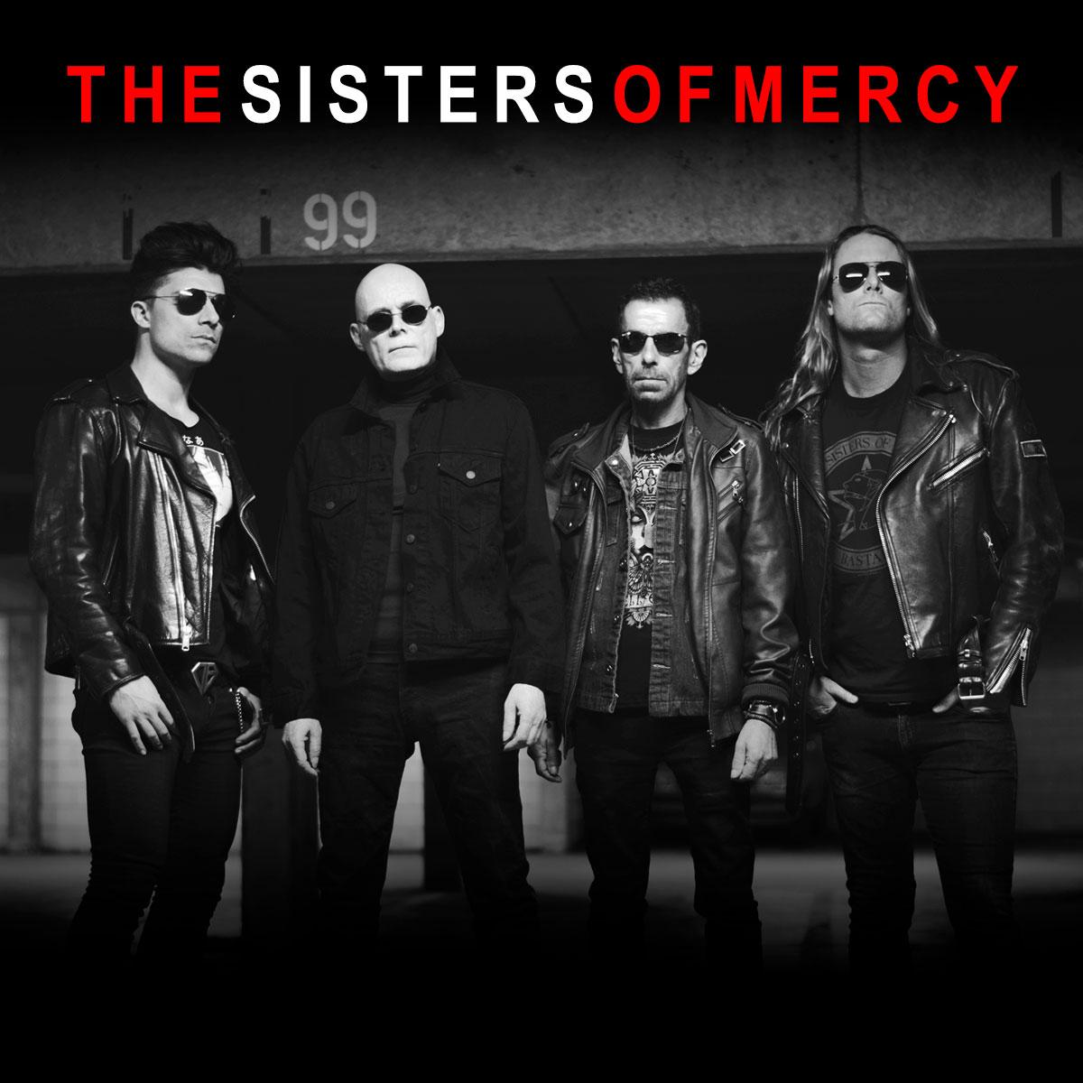

**THE SISTERS OF MERCY - NZ TOUR 2022**

*"It howls, it's grindingly beautiful, and it’s heading your way…"*

UK’s dark rock legends **The Sisters of Mercy** will be returning to New Zealand this October, playing shows in **Auckland** and **Wellington**.

Recently celebrating their 40th anniversary, **The Sisters of Mercy** are one of the most important bands to emerge from the post punk scene, with the imposing presence and the heavily melancholic voice of **Andrew Eldritch** giving their mark. They are a reference point for the dark rock sound and the dark culture in general with their music gaining cult status and has since been cited as a major influence by the likes of **Metallica, Nine Inch Nails** and **My Chemical Romance**.

A statement accompanying the tour news says, "*It howls, it's grindingly beautiful, and it's probably heading your way.*” Continuing in a similarly poetic vein, the statement adds, "*New and hence unreleased songs make up half of any Sisters’ set these days, although the classics get a good thrashing in rotation. Having derived their light show from the Big Bang (gleefully inventing rave lighting in the process), the Sisters see no reason to tone it down, and will be exploding in all their usual glory*.".

Over the course of four decades The Sisters of Mercy released three, utterly brilliant and hyper influential studio albums scaling the charts around the globe and have amassed a legion of devoted fans who flock to see classics such as *Lucretia My Reflection*, *Temple of Love* and *This Corrosion,* a testament to their incredible live shows.

*“[The Sisters are…] a lean glittering groove machine for the new millennium, leaving the sullenly anachronistic reformations of their contemporaries far behind.” – Metal Hammer*

**THE SISTERS OF MERCY – NZ TOUR 2022**

Tues 25 Oct: Powerstation, AUCKLAND

Wed 26 Oct: Hunter Lounge, WELLINGTON

TICKETS ON SALE NOW - [MORE INFO](https://sbmpresents.com/tour/the-sisters-of-mercy-2022/)

Publicity Enquiries: Publicity+, [publicity-machine@orcon.net.nz](mailto:publicity-machine@orcon.net.nz), 021 243 6899

**PRESENTED BY SBM PRESENTS**

