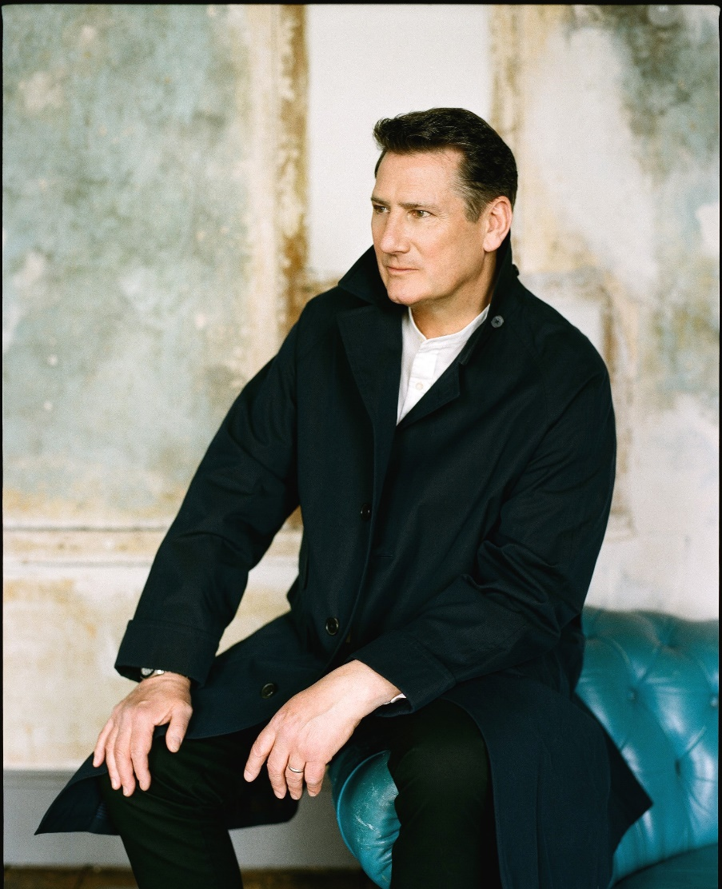

***Destroy All Lines presents***

**Ex Spandau Ballet lead vocalist TONY HADLEY**

**Announces NZ Shows in September 2022**

**TONY HADLEY – 40TH ANNIVERSARY TOUR**

**TONY HADLEY**, former lead singer from one the biggest bands of the 1980s, Spandau Ballet will return to New Zealand to perform in **Christchurch’s James Hay Theatre and Auckland’s Sky City Theatre on Saturday 24 and Sunday 25 September 2022** as he celebrates 40 big years in music.

“***As the world starts to return to some sense of normality and borders have started to open,*** ***I am thrilled that one of the first international tours I will be doing is to Australia and New Zealand. I can’t wait to get back with The Fabulous TH band and perform in front of fans and friends once more”.***

It has been just over forty years since Tony Hadley first released music with his former band Spandau Ballet. Now performing with his band, The Fabulous TH Band, Tony’s unmistakable voice still brims with passion and urgency as it first did all those years ago. Fitting for what will be a big celebration of one of the biggest voices in pop, Tony will perform tracks from across his career both as the voice of Spandau Ballet, and as a solo artist.

From his beginnings at the forefront of the New Romantic movement, Tony earned himself the accolade of being one of pop’s greatest vocalists. Spandau Ballet had numerous chart-topping singles and albums all over the world, including the epic Through the Barricades, the international number one True, and the unofficial London Olympics theme Gold.

As a solo artist Tony has performed across the world both with his band, swing bands, and orchestras. In 2005 he was awarded a Gold Badge from the British Academy of Composers and Songwriters; whilst 2007 saw him win a new legion of fans when he appeared as Billy Flynn in Chicago on the West End stage.

In 2018 Tony released his highly anticipated solo album Talking To The Moon, The album was incredibly well received and became BBC Radio 2’s Album Of The Week and the 1st single Tonight Belongs To Us was Single Of The Week.

In 2019 he was awarded an MBE in the Queen’s New Year Honours List for his services to charity.  
Fans across NZ will be thrilled to hear their favourite Spandau Ballet hits songs, alongside some Tony’s favourite songs of the past 40 years.

**TONY HADLEY – 40th ANNIVERSARY TOUR**

**ON SALE 9am, Friday 3 June -** [**www.destroyalllines.com**](http://www.destroyalllines.com)

**Sat 24 September – CHRISTCHURCH - James Hay Theatre**

**Sun 25 September – AUCKLAND – Sky City Theatre**

[www.tonyhadley.com](http://www.tonyhadley.com) | [www.twitter.com/thetonyhadley](http://www.twitter.com/thetonyhadley) | [www.instagram.com/thetonyhadley](http://www.instagram.com/thetonyhadley)

[www.facebook.com/officialtonyhadley](http://www.facebook.com/officialtonyhadley)

**MEDIA ENQUIRIES: Leesa Tilley @** [**Publicity-machine@orcon.net.nz**](mailto:Publicity-machine@orcon.net.nz) **/ +64 21 243 6899**